**EXPERIMENT 1 Date:31/07/23**

**Title: Study of Linux Commands**

**Aim**: To study and implement various Linux commands

**Theory**: Commands:

1. date - displays current date and time of the system.
2. tput clear/clear - used to clear terminal script.
3. who - displays information about the system users.
4. whoami - current logged in user information.
5. ps - all active processes executed.
6. ls - all files and directories in current working directory.
7. cal - calender of current year.
8. script script_name – creates a file named script_name and records the sessions.
9. cat >filename - create new file with specified name.
10. cat filename - displays content of file.
11. cat >>filename - append to the file.
12. wc filename - is for np, of line, words, characters in file.
13. exit - close the terminal.
14. echo &quot;text&quot;-used to display a message.
15. cd - used to change directory.
16. passwd – to change the password.
17. rm – delete the file.
18. mv – renaming the file.
19. cmp file1 file2 – compares file1 and file2.
20. comm – finds common between two files.
21. diff – find the difference between two files.
22. piping-combining 2 commands.
23. type - used to display location of a command.
24. man - gives the manual for a particular command.
25. uname - for explaining the features of OS.
26. tty - displays the identity of terminals on which you are working.
27. pwd - is for present/print working directory.
28. stdy - change setting of the terminal.
29. bc - opens the basic calculator.
30. mkdir - to create a directory.
31. rmdir – to delte a directory.
32. cd .. – go back to the previous directory.
33. cd – go back the main directory.
34. tree root_directory_name – to display the directory in tree form.
35. chmod – changing the modes of operation of the file.

Output:

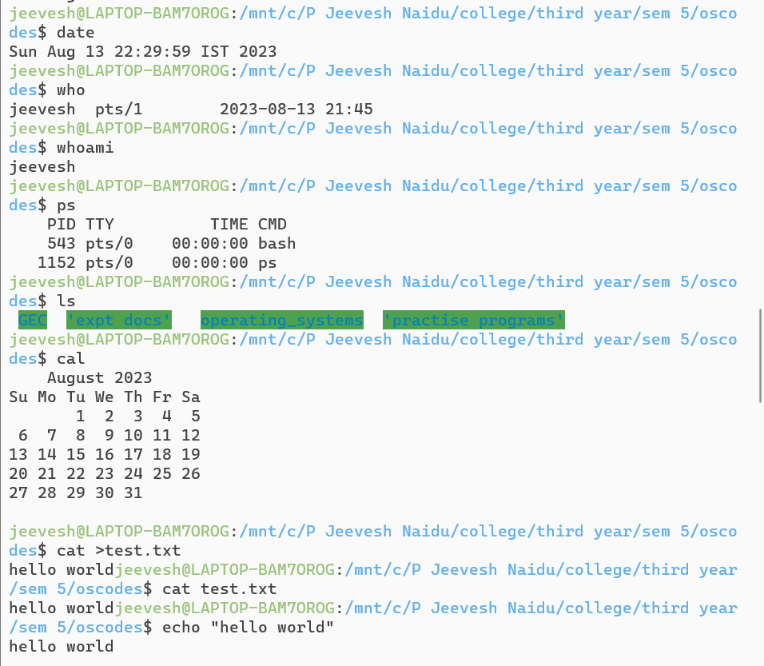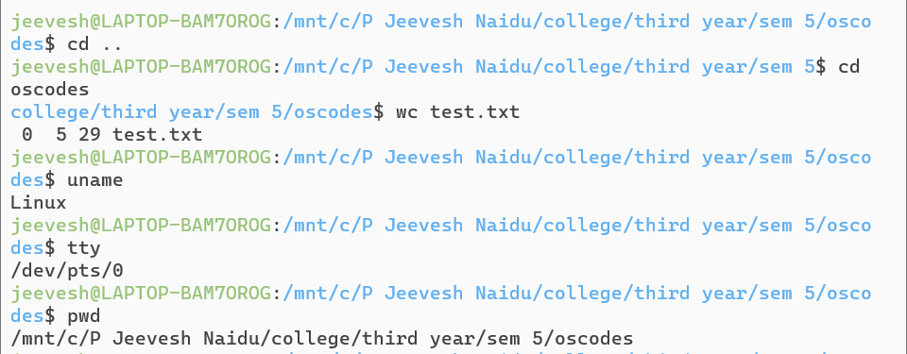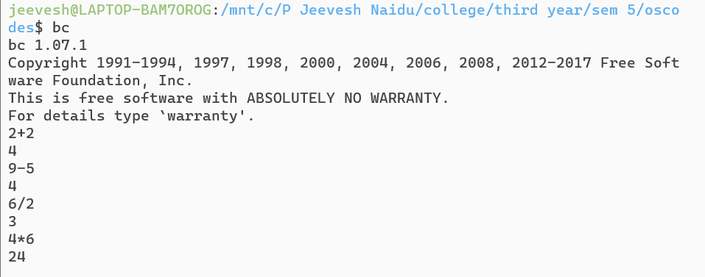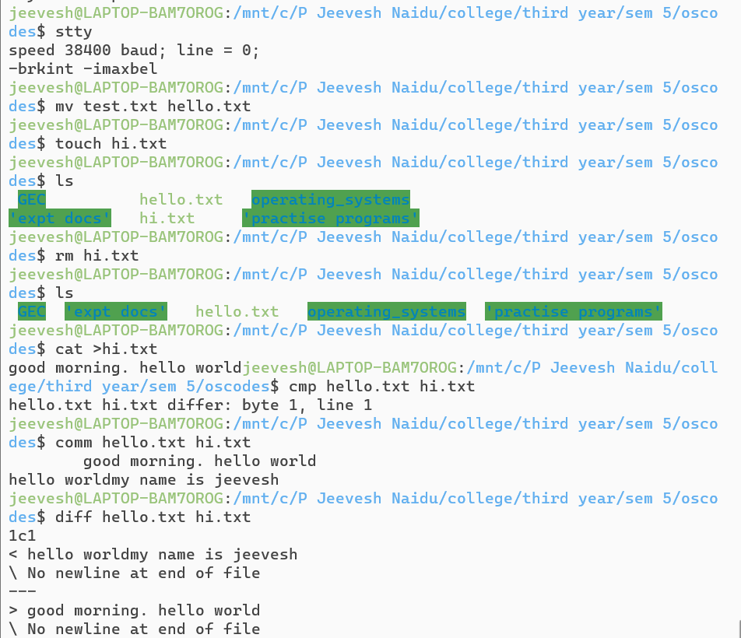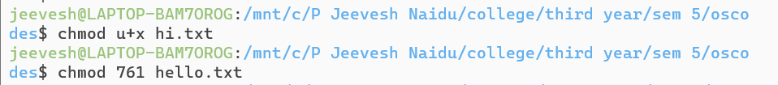

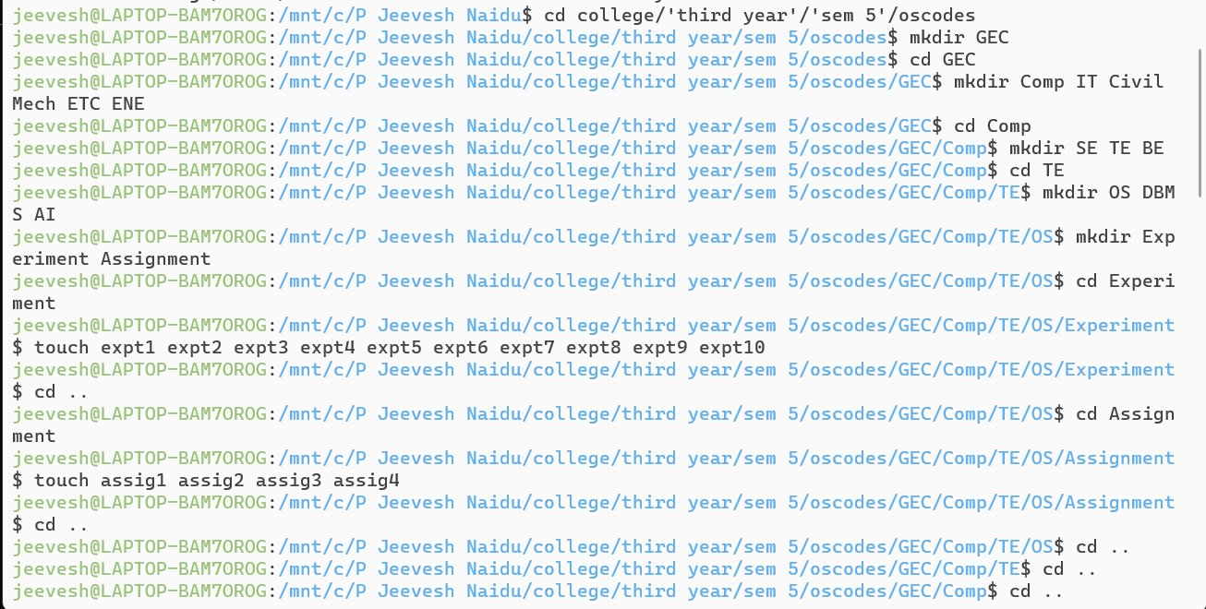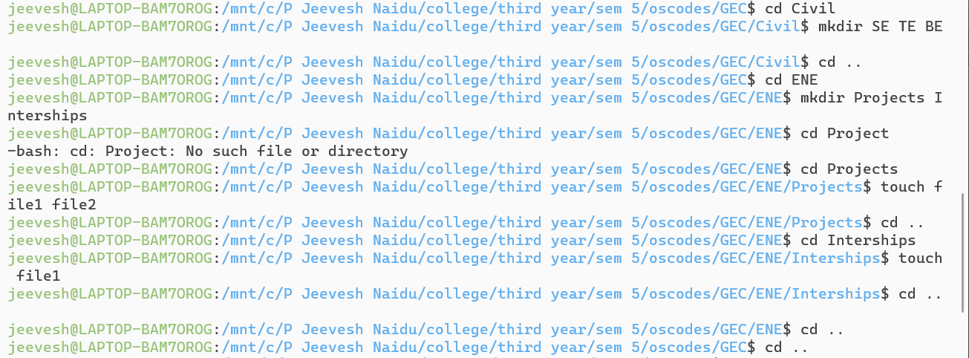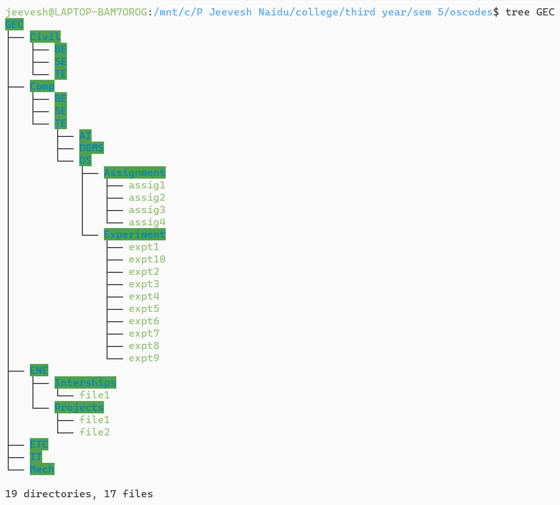

Conclusion:

Various Linux commands were studied and implemented successfully.